Tasks:

1.Create a tuple for storing student information and perform the following functions:
- Print an item of the tuple
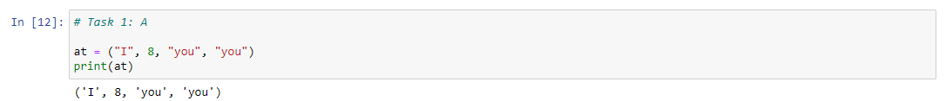
- Check if an element exists within a tuple
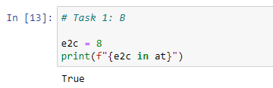
- Check number of times an item has repeated
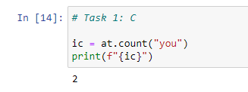
- Remove an item from a tuple
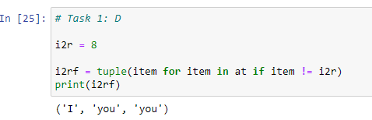
- Slice a tuple
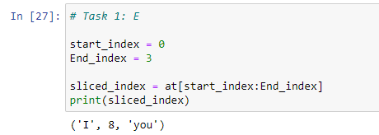
- Get the index of an item of the tuple
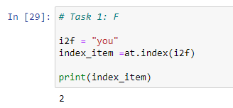
- Print the size of a tuple
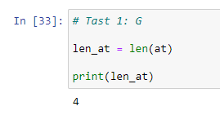
- Modify items of a tuple
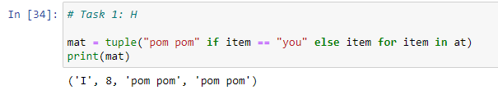

2.Develop a menu driven program for a food hub.
Example:
Please select option:
1- Veg Menu
2- Non-Veg Menu
0- Exit
Enter your choice: 1
You have selected option 1 – Veg
Select from the following options for Veg
1- Veg Burger
2- Veg Pizza
3- Dosa
Enter your choice: 2
Do you wish to continue [Y/N] ? Y
Select from the following options for Veg
1- Veg Burger
2- Veg Pizza
3- Dosa
Enter your choice: 1
Do you wish to continue [Y/N] ? N
Your order is : [“Veg Pizza”, “Veg Burger”]
Perform operations accordingly.
- For the same above example include price. The output will look like
{“Veg Pizza” : 120, “Veg Burger”: 110}. Also print the total price of user choice items.

3. Write a Python script to concatenate following dictionaries to create a new one
Sample Dictionary :
dic1={1:10, 2:20}
dic2={3:30, 4:40}

dic3={5:50,6:60}
Expected Result : {1: 10, 2: 20, 3: 30, 4: 40, 5: 50, 6: 60}

4. Write a Python script to print a dictionary where the keys are numbers between 1 and 15 (both included) and the values are square of keys.
Sample Dictionary
{1: 1, 2: 4, 3: 9, 4: 16, 5: 25, 6: 36, 7: 49, 8: 64, 9: 81, 10: 100, 11: 121, 12: 144, 13: 169, 14: 196, 15: 225}

5.Write a Python program to print all unique values in a dictionary
Sample Data : [{"V":"S001"}, {"V": "S002"}, {"VI": "S001"}, {"VI": "S005"}, {"VII":"S005"}, {"V":"S009"},{"VIII":"S007"}]
Expected Output : Unique Values: {'S005', 'S002', 'S007', 'S001', 'S009'}

6.Write a Python program to combine values in python list of dictionaries.
Sample data: [{'item': 'item1', 'amount': 400}, {'item': 'item2', 'amount': 300}, {'item': 'item1', 'amount': 750}]
Expected Output: Counter({'item1': 1150, 'item2': 300})

7. Write a Python program to get the top three items in a shop.
Sample data: {'item1': 45.50, 'item2':35, 'item3': 41.30, 'item4':55, 'item5': 24}
Expected Output:
item4 55
item1 45.5
item3 41.3

8. Write a Python program to filter the height and width of students, which are stored in a dictionary
Original Dictionary:
{'Cierra Vega': (6.2, 70), 'Alden Cantrell': (5.9, 65), 'Kierra Gentry': (6.0, 68), 'Pierre Cox': (5.8, 66)}
Height > 6ft and Weight> 70kg:
{'Cierra Vega': (6.2, 70)}

9.Write a Python program to extract a list of values from a given list of dictionaries.
Original Dictionary:
[{'Math': 90, 'Science': 92}, {'Math': 89, 'Science': 94}, {'Math': 92, 'Science': 88}]
Extract a list of values from said list of dictionaries where subject = Science
[92, 94, 88]
Original Dictionary:
[{'Math': 90, 'Science': 92}, {'Math': 89, 'Science': 94}, {'Math': 92, 'Science': 88}]
Extract a list of values from said list of dictionaries where subject = Math
[90, 89, 92]

10.Write a Python program to print a tuple with string formatting.
Sample tuple : (100, 200, 300)
Output : This is a tuple (100, 200, 300)

11.Write a Python program to sort a tuple by its float element.
Sample data: [('item1', '12.20'), ('item2', '15.10'), ('item3', '24.5')]
Expected Output: [('item3', '24.5'), ('item2', '15.10'), ('item1', '12.20')]

12.Write a Python program calculate the product, multiplying all the numbers of a given tuple.
Original Tuple:
(4, 3, 2, 2, -1, 18)
Product - multiplying all the numbers of the said tuple: -864
Original Tuple:
(2, 4, 8, 8, 3, 2, 9)
Product - multiplying all the numbers of the said tuple: 27648

13.Write a Python program to calculate the average value of the numbers in a given tuple of tuples.
Original Tuple:
((10, 10, 10, 12), (30, 45, 56, 45), (81, 80, 39, 32), (1, 2, 3, 4))
Average value of the numbers of the said tuple of tuples:
[30.5, 34.25, 27.0, 23.25]
Original Tuple:
((1, 1, -5), (30, -15, 56), (81, -60, -39), (-10, 2, 3))
Average value of the numbers of the said tuple of tuples:
[25.5, -18.0, 3.75]

14.Write a Python program to check if a specified element presents in a tuple of tuples.
Original list:
(('Red', 'White', 'Blue'), ('Green', 'Pink', 'Purple'), ('Orange', 'Yellow', 'Lime'))
Check if White present in said tuple of tuples!
True
Check if White present in said tuple of tuples!
True
Check if Olive present in said tuple of tuples!
False

15.Write a Python program to convert a given list of tuples to a list of lists.
Original list of tuples: [(1, 2), (2, 3), (3, 4)]
Convert the said list of tuples to a list of lists: [[1, 2], [2, 3], [3, 4]]
Original list of tuples: [(1, 2), (2, 3, 5), (3, 4), (2, 3, 4, 2)]
Convert the said list of tuples to a list of lists: [[1, 2], [2, 3, 5], [3, 4], [2, 3, 4, 2]]

PART B
(PART B: TO BE COMPLETED BY STUDENTS)
(Students must submit the soft copy as per following segments within two hours of the practical. The soft copy must be uploaded on the Teams or emailed to the concerned lab in charge faculties at the end of the practical in case the there is no Black board access available)
Roll No. | Name:
Program: | Division:
Semester: | Batch :
Date of Experiment: | Date of Submission:
Grade :

B.1 Software Code written by student:
(Paste your Python code completed during the 2 hours of practical in the lab here)

B.2 Input and Output:
(Paste your program input and output in following format. If there is error then paste the specific error in the output part. In case of error with due permission of the faculty extension can be given to submit the error free code with output in due course of time. Students will be graded accordingly.)

B.3 Conclusion:
(Students must write the conclusion as per the attainment of individual outcome listed above and learning/observation noted in section B.1)

